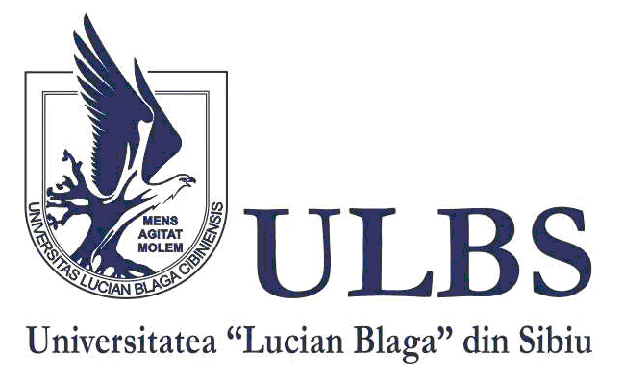

INTERNATIONAL
CONFERENCE

The Transnistrian Conflict Files
- third edition -

SEPTEMBER 20th - 22nd, 2019

BACĂU, ROMÂNIA

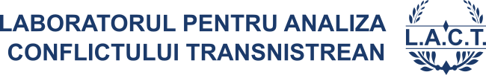

ORGANIZER:

LUCIAN BLAGA UNIVERSITY OF SIBIU /
THE TRANSNISTRIAN CONFLICT ANALYSIS LABORATORY

PLACE:

BACĂU, THE ADMINISTRATIVE PALACE
- CONFERENCE ROOM OF THE COUNTY
(Mărășești Street, 2)

OPENING:

SEPTEMBER 21st 2019, 9.00 A.M.

Web:
http://www.lact.ro/2019/05/28/international-conference-the-transnistrian-conflict-files-iiird-edition/

ORGANIZING COMMITTEE:

- Eugen Străuţiu – „Lucian Blaga” University of Sibiu (chairman)
- Vasile Tabără – „Lucian Blaga” University of Sibiu
- Tatiana Toma – „Dunarea de Jos” University of Galați
- Marius Şpechea – „Lucian Blaga” University of Sibiu
- Mihai Melintei – „Lucian Blaga” University of Sibiu
- Liana Cupşa – „Lucian Blaga” University of Sibiu

SCIENTIFIC COMMITTEE:

- Eugen Străuţiu – „Lucian Blaga” University of Sibiu
- Vitaly Gămurari – Free International University of Moldova, Chişinău
- Eduard Ţugui - University of European Political and Economic Studies „Constantin Stere”, Chișinău
- Leonid Litra - New Europe Center, Kyiv
- Anatoly Dirun – School for Political Research, Tiraspol
- Aurelian Lavric - Armed Forces Military Academy „Alexandru cel Bun”, Chişinău

AGENDA
SEPTEMBER 20th, 2019
ARRIVAL OF PARTICIPANTS

SEPTEMBER 21st, 2019

9.00 – 9.10: OFFICIAL OPENING

9.10 – 9.30: LACT REPORT (Professor Eugen Străuțiu)
Including book presentations:
- Eugen Străuțiu, Transnistrian Bibliography, TechnoMedia, Sibiu, 2019
- „The Yearbook of the Laboratory for Transnistrian Conflict Analysis”, II, 1/2018

9.30 – 11.00: SCIENTIFIC PANEL: The Transnistrian Conflict Files. Solutions to develop society on the two banks of the Dniestr – Moderator: Eugen Străuțiu

- Eduard Țugui (University of European Political and Economic Studies „Constantin Stere”, Chișinău) - A new European security architecture and a „new project” for the settlement of the Transnistrian conflict
- Alla Ostavnaia (Sociological Association of Transnistria, Tiraspol) - Identities of the Transnistrian population
- Natalia Putina (State University of Moldova, Chișinău) - Phenomenon of the „de Facto States” and Nation identity construction - Transnistrian paradigm
- Anatoly Dirun (School for Political Research, Tiraspol) - Features of political communication between the Republic of Moldova and Transnistria in the conditions of the „frozen conflict”
- Vitaly Gamurari (Free International University of Moldova) - Amnesty and punishment in the context of transitional justice and the reconciliation of a post-conflict society
- Veaceslav Popescul („Taras Sevcenco” University, Tiraspol) - Respect for human rights in Transnistria: problems, characteristics and independent reports
- Nikolai Tsveatkov (Institute of Legal, Political and Sociological Research, Chișinău) - Neutrality policies in international experience: lessons for the Republic of Moldova
- Ernest Vardanean (State University of Moldova, Chișinău) - New Leadership in Moldova and new opportunities for Transnistrian settlement process: Domestic and foreign factors
- Vladimir Sterpu (State University of Moldova, Chișinău) - The problems of cross-border crime in Transnistria in the perception of criminal prosecution officers
- Nonna Mihălcean (Resource Center for Teenagers and Young People, Bălți) - The role of young people in the Transnistrian conflict

11.00 – 11.30: COFFEE BREAK

11.30 – 13.00: SCIENTIFIC PANEL: The Transnistrian Conflict Files. Solutions to develop society on the two banks of the Dniestr (second part) – Moderator: Eugen Străuțiu

- Igor Shornikov (Institute of Socio-Political Studies, Tiraspol) - Peacekeeping operation and Russia's military presence on the Dniester in the new political reality
- Zurab Todua (The Slavonic University, Chișinău) - „The Revolution of the Ambassadors” from June 3-14 in the Republic of Moldova and the influence on the Transnistrian negotiation process
- Aurelian Lavric (Armed Forces Military Academy „Alexandru cel Bun”, Chişinău) - Right and Left Banks of the Dniester Parts of the Moldovan State: Common Values and Interests
- Luiza Dorosenco (Media Center, Tiraspol) - Roma population in Transnistria
- Alexandru Zubco (Office of The Peoples Advocate / Ombudsman of Chișinău) - Human rights conflict in the Transnistrian region
- Diana Bencheci, Alexander Kurtskhalia (State University of Moldova, Chișinău) - Institutional parameters of frozen conflicts in Transnistria, Abkhazia and South Ossetia: a comparative study
- Eugen Străuțiu („Lucian Blaga” University of Sibiu) –Addressing the Transnistrian problem by research organizations in Chișinău. IDIS Viitorul and Promo-Lex: a comparative analysis
- Tatiana Toma („Dunarea de Jos” University of Galați) - The vision of the Ukrainian civil society on the Transnistrian conflict, after 2014
- Marius Șpechea („Lucian Blaga” University of Sibiu) - The activity of the sectoral working groups and the evolution of the Transnistrian settlement process 2018-2019
- Mihai Melintei („Lucian Blaga” University of Sibiu) - The directions and instruments of foreign policy of the Russian Federation in the Transnistrian problem
- Nicoleta Ciobanu („Lucian Blaga” University of Sibiu) –Transnistrian issue in the vision of the Institute for Strategic Studies in Chișinău - projects, analyzes, policy proposals

13.00 – 14.00: WORKSHOP: The Transnistrian Conflict: Format of the problem and possible solutions – Moderator: Eugen Străuțiu
- Constantin Constantinescu, Cătălina Pralea (The Group for Social and Cultural Dialogue, Adjud) - New project opportunities under the aegis of The Group for Social and Cultural Dialogue
- Alexandr Stetsiuk, Vladimir Bodnarenko (representing the Chief-Negotiator of Tiraspol) - Stage and perspective of the negotiation process. The point of view of Tiraspol
- Ivan Țurcan, Marin Bodrug (representing the Chief-Negotiator of Chișinău) – Stage and perspective of the negotiation process. The point of view of Chișinău

14.30 – 15.30: LUNCH
15.30 – 19.00: FREE TIME
19.00 – 20.00: DINNER

SEPTEMBER 22nd, 2019

DEPARTURE OF PARTICIPANTS

The Transnistrian Conflict Analysis Laboratory (LACT) works as a research program of the Center for Research in Political Science, International Relations and European Studies (research unit under the Department of International Relations, Political Sciences and Security Studies - Faculty of Social and Human Sciences of „Lucian Blaga” University of Sibiu).
LACT aims to initiate, coordinate and capitalize scientific research projects related to the roots, forms of expression, status and perspectives of the Transnistrian conflict.
Address: 550324-Sibiu, Calea Dumbrăvii nr. 34, et. II, room 12
Phone: 0040/734306434, Fax: 0040/269/422169

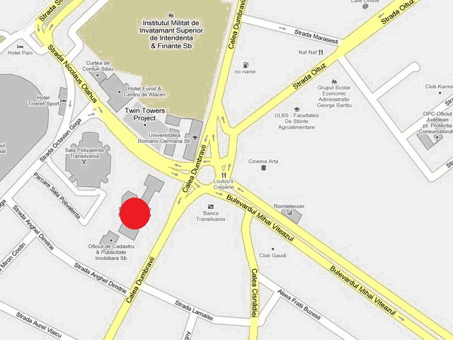

Website: http://www.lact.ro/
E-mail: office@lact.ro

